Library Manger is also known as Libman.

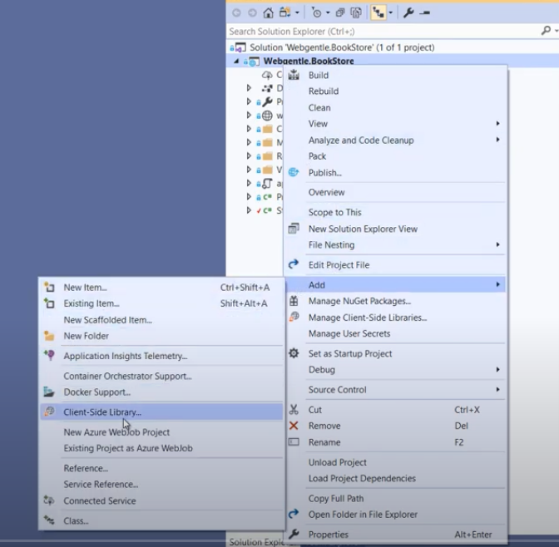

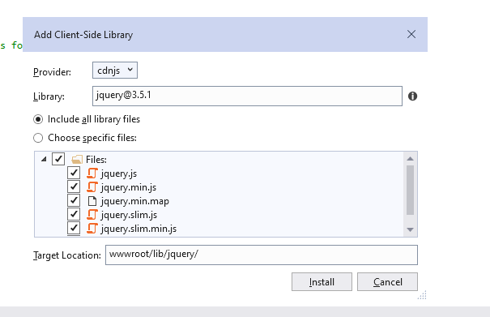

Once we install there will be a new file appearing in our solution explorer named **libman.json**. This will contain the configuration of the installed libraries. The beinifit of using this is, we can at later point change the versions easily.